Introduction:
Convection, it is the force that drives all of our planet's motion. From the deepest magma to the slightest breeze in the air brushing our skin, the force behind the movement is convection. Convection is one of the ways that heat moves in a fluid.
In the ocean, convection currents are responsible for the mixing and movement of the waters around the globe. In this lab we will be observing convection currents modeled with hot and cold water and food coloring.

Objectives:
Model and observe convection currents.
Observe how temperature differentials effect the movement of water in a shallow pan.
Observe the effect of seafloor shape and manmade structures on the movement of convection currents.

Materials:
Each group or team will receive one set of materials.
1. One plastic pan to hold water.
2. 4 beakers to support pan and to contain the warm water.
3. Food coloring.
4. Water.
5. White paper
7. Data recording sheets.
8. Small rocks or rubber stoppers for the seafloor features.
General notes:
You will be handling HOT water in this lab. Please use caution.
You will be completing five trials in this experiment, each time you begin a new trial you will
want to get a new pan of water and refresh your heat source if it has cooled.
Handle the pans carefully they break easily. Use two hands!!
You will be placing the drop of food coloring in different locations and carefully observing its pattern of movement. You will record your observations in detailed sketches done with colored pencils and including directional arrows.
Be careful not to bump the tables or you will disturb your currents.
Using only a few drops will allow you to see the currents most clearly.

Basic diagram of pan and beakers.
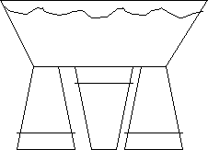

Support Heat Source Support

Trial A. No heat source

Place a few drops of food coloring in the still water with no heat source.
The drop of color should be placed at the center of the pan, right on the bottom.
Draw what happens to the food coloring as you look at it from the side and top views. Be sure to include arrows.
Write a brief description of what you see.

Trial B. Heat in Center /Drop close to side / bottom of pan
Place the drop of food coloring in the still water with heat source under the center.
The drop of color should be placed near the side of the pan, right on the bottom.
Draw what happens to the food coloring as you look at it from the side and top views. Be sure to include arrows.
Write a brief description of what you see.

Trial C. Heat in Center /Drop on top of pan
Place the drop of food coloring in the still water with heat source under the center.
The drop of color should be placed near the top of the pan.
Draw what happens to the food coloring as you look at it from the side and top views. Be sure to include arrows.
Write a brief description of what you see.

Trial D. Heat on one side / ice on other side
Place two drops of food coloring in the still water with heat source under the side of the pan and a baggie of ice near one edge.
One drop of color should be placed near the side of the pan, right on the bottom over the heat source. The second near the ice bag.
Draw what happens to the food coloring as you look at it from the side and top views. Be sure to include arrows.
Write a brief description of what you see.

Discussion Questions.
Answer, using complete sentences, the following questions. You may need to consult outside resources such as your book to answer these questions.
Describe how the currents moved in the pans. Did the color mix with the water? Why?

In the case of the real ocean what is the heat source?

How might currents help the fishing industry?

Describe two other places you might have seen or can expect to find convection currents other than in the ocean?

Data Collection Form
Trial A
Draw what you saw Explain what you saw
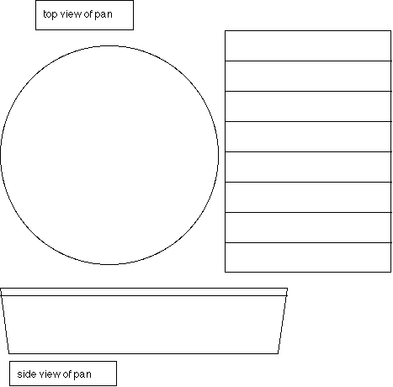
_______________________________
_______________________________
_______________________________
_______________________________
_______________________________
_______________________________
_______________________________
_______________________________
_______________________________
_______________________________
_______________________________
_______________________________
_______________________________

Data Collection Form
Trial B
Draw what you saw Explain what you saw
_______________________________
_______________________________
_______________________________
_______________________________
_______________________________
_______________________________
_______________________________
_______________________________
_______________________________
_______________________________
_______________________________
_______________________________
_______________________________

Data Collection Form
Trial C
Draw what you saw Explain what you saw
_______________________________
_______________________________
_______________________________
_______________________________
_______________________________
_______________________________
_______________________________
_______________________________
_______________________________
_______________________________
_______________________________
_______________________________
_______________________________

Data Collection Form
Trial D
Draw what you saw Explain what you saw
_______________________________
_______________________________
_______________________________
_______________________________
_______________________________
_______________________________
_______________________________
_______________________________
_______________________________
_______________________________
_______________________________
_______________________________
_______________________________

