1.

Which label should be placed on the x-axis?

Which label should be place on the y-axis?

What conclusion can you draw from this graph?
A. Speed is a change in direction
B. Speed is a change in acceleration
C. Speed is a change in distance over time
D. Speed is a change in temperature over time.
Put the objects in order from FASTEST to SLOWEST.
_______________________________

Are the speeds constant or changing?
_______________________________
Are they moving toward or away from the origin?
_______________________________

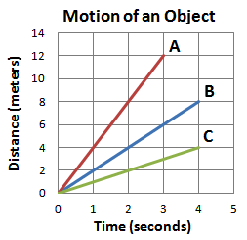
2.

.
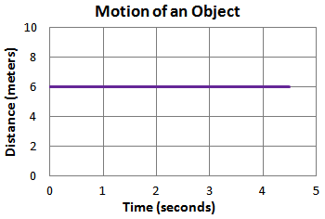
3.
Which of the following statement is true of the above graph?
A. An object is moving at a constant speed of 6 m/s away from the origin
B. An object is moving at a variable speed away from the origin.
C. An object is standing still on the origin.
D. An object is standing still at a distance of 6 meters from the origin.

Does the object have speed?
______________________________
Is the object in motion?
______________________________
How do you know?
______________________________

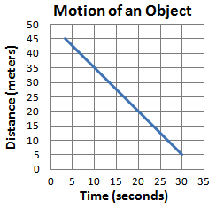
Is the object moving away from or toward the origin?
_______________________________
How do you know if the object is moving toward or away from the origin?
_______________________________
_______________________________
Is the speed constant or changing?
_______________________________
How do you know if the speed is constant or changing?
_______________________________
_______________________________

4.

What is happening in the graph shown above?
A. The object is moving at a constant speed toward the origin
B. The object is standing still
C. The object is moving at a constant speed away from the origin
D. The object’s speed is changing
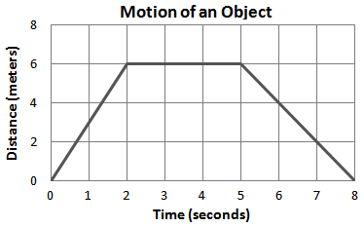
5.

What is happening in the graph?
A. The object moves away from the origin at a speed of 6 m/s, stands still 6 m away from the origin for 3 seconds, then moves toward the origin at a speed of 8 m/s.
B. The object moves away from the origin at a speed of 3 m/s, stands still 6 m away from the origin for 3 seconds, then moves toward the origin at a speed of 2 m/s.
C. The object moves toward the origin at a speed of 3 m/s, stands still 6 m away from the origin for 3 seconds, then moves away from the origin at a speed of 2 m/s.
D. The object moves toward the origin at a speed of 6 m/s, stands still 6 m away from the origin for 3 seconds, then moves away from the origin at a speed of 8 m/s.
Find the speed for each of the three segments of the object’s movement.
A
B
C

What is happening in section B?
_______________________________

Describe the objects motion relative to the point of origin for each segment.
A
B
C

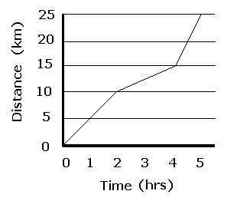
6.

Is the speed constant or changing?
_______________________________
How do you know?
_______________________________
_______________________________
What is the speed of the object for each segment of the trip?
A
B
C
Emma is hiking. She travels more slowly through some areas of the trail than through others. The graph below shows the distance Emma traveled with time.
What is Emma’s average speed on her hike?
A. 5 km/h
B. 10 km/h
C. 25 km/h
D. 7.5 km/h

7. Use the graph below of a 40 kilometer bike ride to answer each question.

A. What was the rider doing from 11:00 – 12:00? How do you know?

B. What was the rider’s average speed for the whole trip?

C. What was the rider’s average speed for the last 2 hours?

D. During what time period is the rider traveling at the fastest speed?

